Endocrine Diseases Case Studies

Endoc1: Graves Disease
HISTORY
A 22-year-old woman who is 7 months pregnant complains of heat intolerance, palpitations, extreme fatigue and exertional dyspnea. She has had prominent eyes for the past 6 months. In addition, several months ago she developed skin lesions on her legs.
EXAMINATION
She is an anxious, hyperkinetic, flushed young lady who is obviously pregnant. Her pulse is 105, blood pressure 140/ 70 respirations 16 and temperature 98.60 F. Her eyes are prominent (Fig. 7.1) and measure 22 mm from the lateral orbital rim to the front border Of the cornea bilaterally. Extraocular muscle function is intact. The thyroid is estimated to be 50 grams to palpation. There is a systolic bruit and a lateral venous hum over the thyroid. The precordium is hyperdynamic with a loud Sl, pulmonary ejection murmur and summation gallop. She has several indurated non tender raised areas on both legs. Her skin is warm, moist and smooth. She has a tremor of her outstretched hands. The fetal heart rate is normal. The remainder of the physical examination is unremarkable.
LAB DATA
- T4 = 19.2 ug/dl
- T3RU 29%
- FT4I 18.3
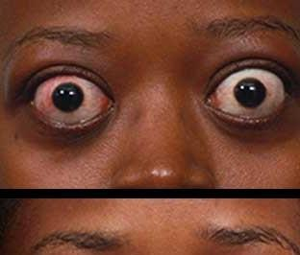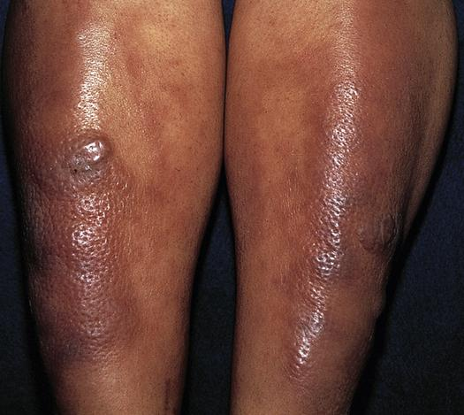
The patient has prominent eyes with edema of the eyelids and conjunctival edema and injection.

Citation: Mazzaferri, Ernest L. Endocrinology Case Studies : a Compilation of 53 Clinical Studies. 3rd ed. Garden City, N.Y.: Medical Examination Pub. Co., 1981.

Endoc2: Diabetes Insipidus
HISTORY
An 18-year-old restaurant manager is referred to you for evaluation of excessive thirst and polyuria. He was well until about 2 years ago when he had the sudden onset of polyuria and excessive thirst which has persisted. He drinks an estimated 7 to 8 quarts of water daily, and has a distinct preference for ice water. He has nocturia 3 or 4 times each night. He otherwise feels well and has no specific complaints, except that he notes his voice is high-pitched and believes that recently his vision is somewhat blurred. He shaves once a week. He denies decreased libido and states that he is capable of sustaining penile erection and has normal intercourse.

EXAMINATION
He is an eunuchoidal appearing young man who has almost no facial hair. His blood pressure is 106/70 mm Hg supine and 96/78 standing, pulse 98, respirations 12 and temperature 98F. His visual fields are grossly normal, but his visual acuity is slightly reduced. Fundiscopic exam is normal except for pale optic discs. Extraocular muscles are intact, including ability to direct his gaze upward. He has sparse pubic and axillary hair and his testes measure 2.5 cm in the long diameter. His scrotum and penis are hyperpigmented and he has scrotal wrinkling. His penis appears small but the remainder of his physical examination is normal.

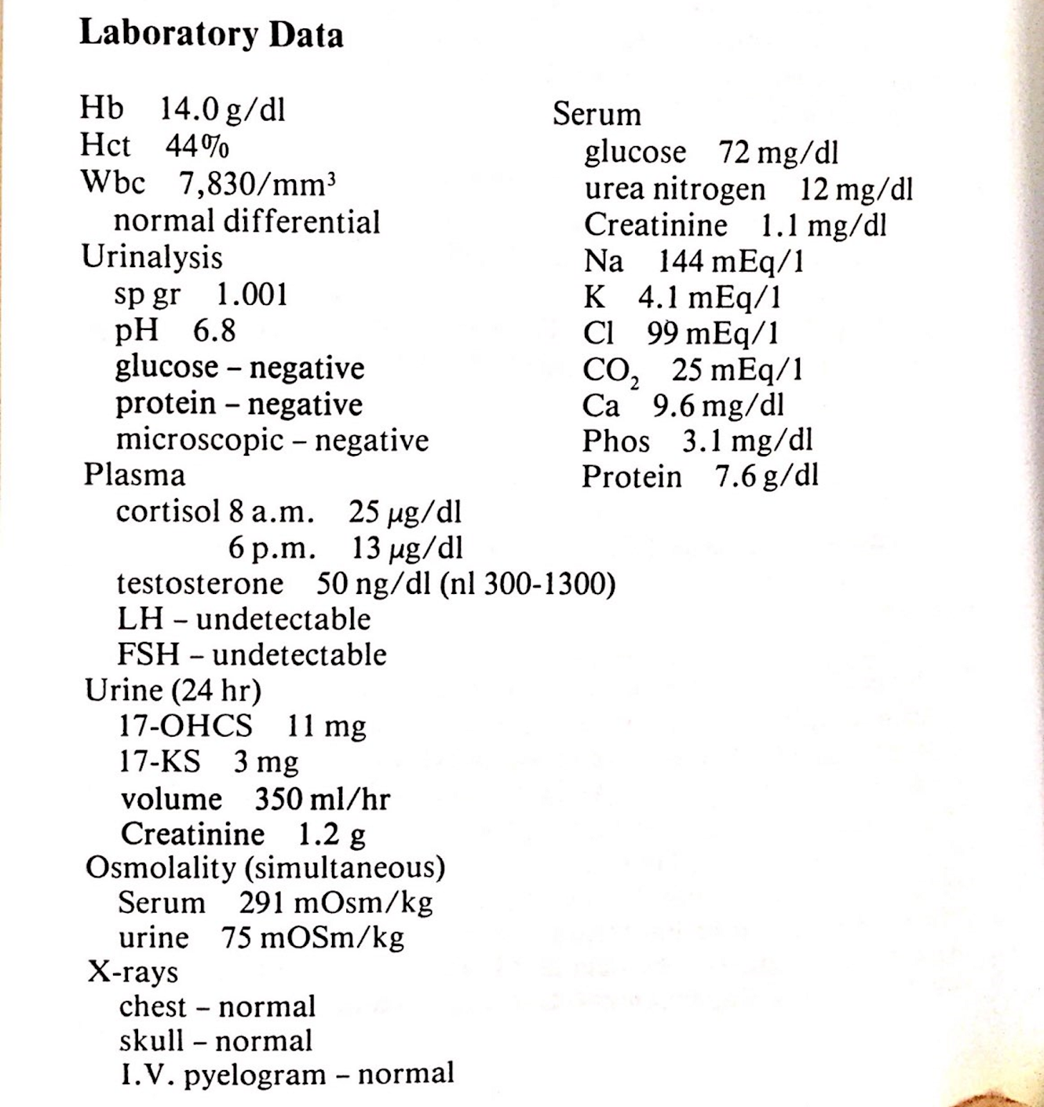

Citation: Mazzaferri, Ernest L. Endocrinology Case Studies : a Compilation of 53 Clinical Studies. 3rd ed. Garden City, N.Y.: Medical Examination Pub. Co., 1981.

Endoc3: Diabetes Mellitus
HISTORY
A 63-year-old housepainter is brought to the emergency room unconscious. He was apparently in good health until one week before admission, when he developed an insatiable thirst which he attempted to satisfy with large volumes of beer and soda pop. He complained of nocturia for the last several days, and yesterday had several bouts Of diarrhea. He took to his bed yesterday and was found unconscious this morning and brought to the emergency room by his family. He takes no drugs, has not seen a physician for several years and works regularly. His previous health has been good. There is no significant family history.

EXAMINATION
He is a deeply unconscious, acutely ill man who has several focal right-sided seizures during your examination. His skin and mucous membranes are dry and his ocular globes are quite soft. His blood pressure is 98/70 mm Hg, pulse 120, temperature 101 OF. rectally and his unlabored respirations are 13 per minute. No odor Of acetone is detected on his breath. Except for minimal hepatomegaly, absent knee reflexes and bilateral Babinski reflexes' his examination is otherwise unremarkable.
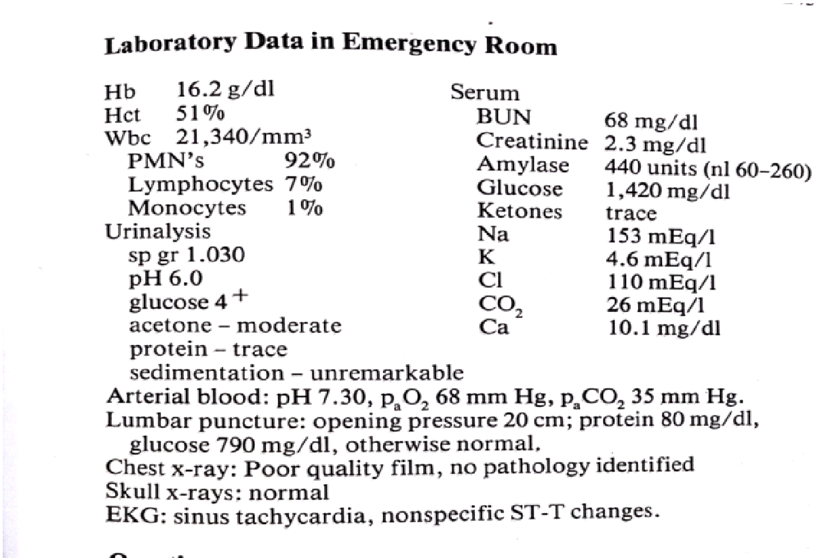

Citation: Mazzaferri, Ernest L. Endocrinology Case Studies : a Compilation of 53 Clinical Studies. 3rd ed. Garden City, N.Y.: Medical Examination Pub. Co., 1981.

Endoc4: Graves Disease

HISTORY
A housewife complains of nervousness and fatigue which became apparent about One year ago. She has lost 6 kg but denies anorexia. Recently she has been unable to perform routine household activities because of fatigue. palpitations and exertional dyspnea. Her symptoms all seem heightened by the current summer heat which caused her to perspire excessively. Her menstrual periods, regulated by oral contraceptives, are normal. Her only other complaint, which began about two years ago, is the appearance of areas of depigmentation of the dorsa of her hands and feet.

EXAMINATION
She is a thin. hyperkinetic, anxious appearing woman who dominates the interview With a steady stream Of speech. Her blood pressure is 130/70 mm Hg, pulse 120 per minute. respirations 18 per minute and temperature 98F. She has a stare and her prominent eyes show no chemosis or lid edema. By exopthalmometry the ocular globes measure 18 mm from the lateral orbital margin. The thyroid gland. diffusely enlarged and estimated to weigh grams. has a systolic bruit. Lateral to the gland in the right supraclavicular fossa there is a continuous venous bruit. Her sparse hair is of very fine texture, and her generally hyperpigmented skin is warm and smooth. There are several prominent areas of vitiligo on her hands and feet. and her nails appear to be separating from the nail beds. The precordium is hyperdynamic, and the forceful. diffuse apical impulse is 10 cm from the mid-sternum. The heart rhythm is regular and the first heart sound is accentuated. A pulmonic systolic ejection click and murmur and a prominent apical mid-diastolic rumble are present. The lungs are clear. Her reflexes are brisk she has a fine tremor Of the outstretched hands.
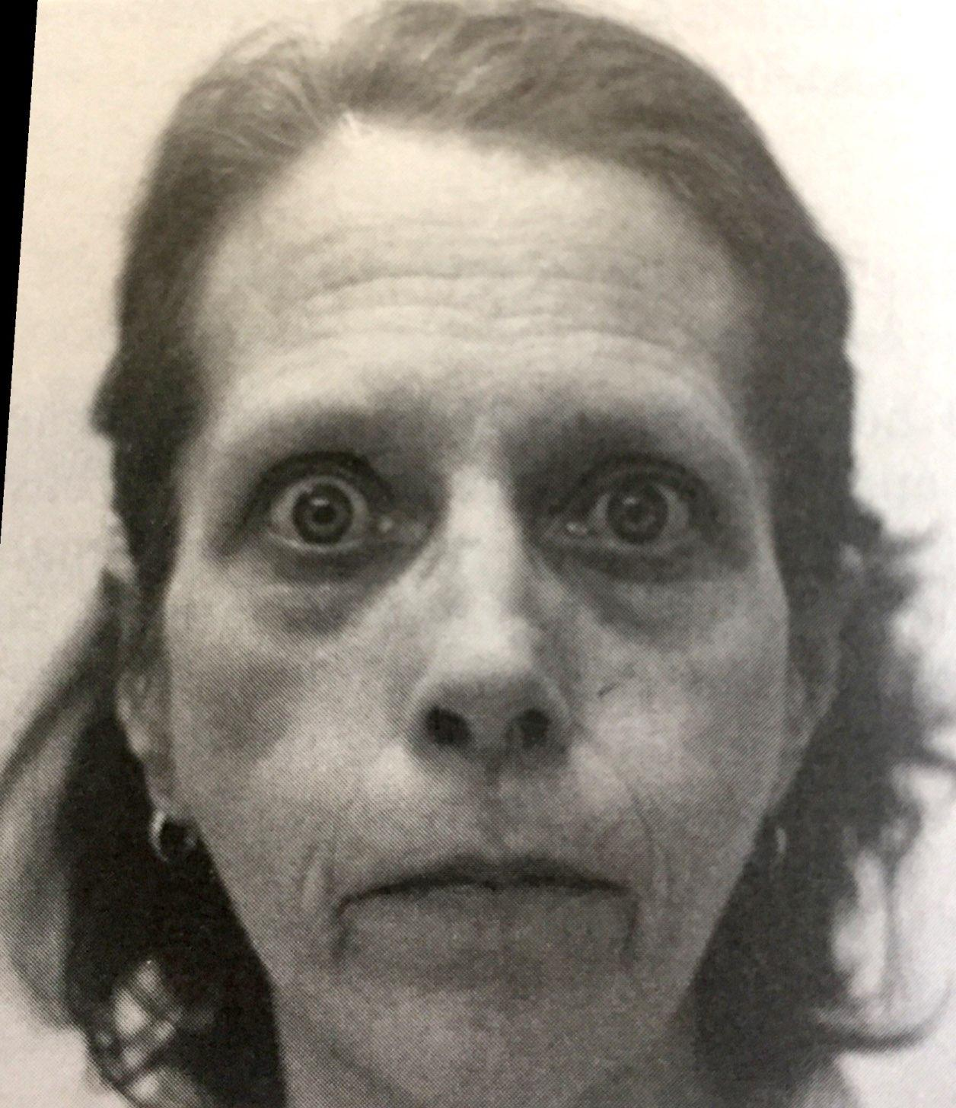
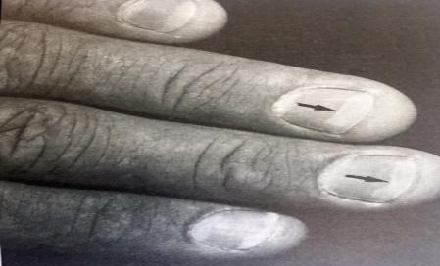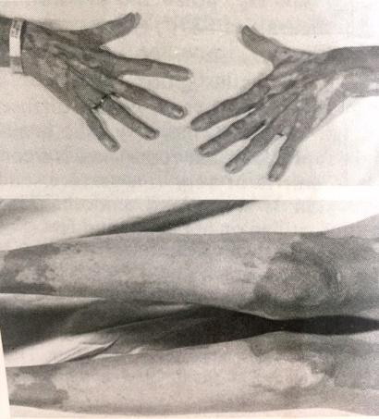
Citation: Mazzaferri, Ernest L. Endocrinology Case Studies : a Compilation of 53 Clinical Studies. 3rd ed. Garden City, N.Y.: Medical Examination Pub. Co., 1981.

Endoc5: Hypothyroidism

HISTORY
A 28-year-old woman, a registered nurse, comes to your office complaining of fatigue, nervousness, and palpitations. She had been in good health until 4 months ago when, shortly after the delivery of her third child, she began experiencing excessive fatigue which she attributes to caring for two small children and a newborn. Her pregnancy, labor, and delivery were normal and her new child, a boy, seems in good health. Although she gained 20 pounds during her pregnancy, going from her usual weight of 115 pounds to 135 pounds at the time of delivery, she now weighs only about 109 pounds despite a normal appetite. Following delivery, she developed sparse lactation that ceased spontaneously. When her menses resumed she began taking birth control pills. During the interview she suddenly begins crying and says there have been a number of "problems" during the past month, particularly bet- ween her and her physician-husband. She admits being abrupt, anxious, emotionally labile and disinterested in sex, and indicates that she has been suffering from insomnia. She complains Of being excessively warm "all of the time" and of perspiring much more than is usual for her. She volunteers that she feels "thyrotoxic"
Her husband obtained a serum T 4 for her which was reported to be "high". You discover that during puberty she had a small asymptomatic goiter that apparently regressed spontaneously over a period of about a year. Her family is generally healthy except for her mother who, at age 48, started to feel chronically fatigued and is now taking thyroid hormone.

EXAMINATION
The patient is flushed, obviously hyperkinetic, anxious and emotionally labile. Her pulse is 110 beats per minute and regular, she is afebrile. Pertinent physical findings include ocular lid lag and stare but no proptosis and no conjunctival injection or extraocular muscle dysfunction. She has a small, firm, symmetric, non tender goiter, estimated to be about 40 grams, with no palpable nodules. Her precordium is slightly hyperdynamic. The first and second heart sounds are louder than normal and she has a faint systolic ejection murmur along the left sternal border. There is a fine tremor of her extended fingers. Her skin is warm, moist and flushed. Deep tendon reflexes are brisk but symmetric. The remainder of the physical examination results are normal.

LAB DATA
Pertinent laboratory data showed: WBC 6300/mm³ with normal differential, Hb 14.2 g/dl, Hct 43%, serum T4 17 ug/dl (nl 4-12), serum T₃RU 37% (nl 25-35), free thyroxine index (FT₄I) 18 (nl 4-12), serum calcium 10.6 mg/dl (nl 9.0-10.2), serum alkaline phosphatase 25 units (nl 5-13).
Further laboratory evaluation shows thyroidal ¹²³ I uptake to be 1% at 24 hours.

Citation: Mazzaferri, Ernest L. Endocrinology Case Studies : a Compilation of 53 Clinical Studies. 3rd ed. Garden City, N.Y.: Medical Examination Pub. Co., 1981.

Endoc6: Hypothyroidism – Myxedema
HISTORY
A 57.year-old woman complains of progressive difficulty with her hearing. She also has noticed muscle cramps, chest pain and acral paresthesias for about one year. She is frequently awakened by severe leg cramps and chest pain which spontaneously remit within 30 minutes. The chest pain is described as a "cramp" which is located across the anterior chest and is nonradiating.
Neither chest pain nor muscle cramps occur with exertion. She also complains Of dry skin and puffy eyelids. She has no other complaints. Her past medical history is unremarkable, except that she took thyroid hormone for a number Of years but discontinued it two years ago because of nervousness, heat intolerance and palpitations.

EXAMINATION
She is an alert, rather slow speaking, almost deaf lady who is hoarse. Her skin is dry, coarse and has a yellow tint. Supine blood pressure in both arms is 180/110 mm Hg; standing, it is 170/102.
Pulse is 47 beats per minute, respirations 10 per minute and temperature 97 degree F. She has coarse, brittle hair, thin eyebrows and moderate blepharoptosis. NO thyroid tissue is palpable.
The cardiac PMI is not palpable, and there is retrosternal and right sternal dullness to percussion. The heart sounds are distant, and no murmurs or gallops are present. Deep tendon reflexes have a
sluggish return, and there is mild generalized muscle weakness.
Light touch and pain perception are decreased in both index fingers and thumbs. Percussion of the ventral wrist and forced flexion of the wrist elicits pain in both index fingers. The remainder of her examination is unremarkable.

Citation: Mazzaferri, Ernest L. Endocrinology Case Studies : a Compilation of 53 Clinical Studies. 3rd ed. Garden City, N.Y.: Medical Examination Pub. Co., 1981.

Endoc7: Hypothyroidism
HISTORY
Mrs. …, 35 years old, housewife, normotensive, nondiabetic, hailing from …, presented with the weight gain and generalized swelling of the whole body for 2-3 months, which is progressively increasing despite her less appetite. The patient also complains of intolerance to cold and prefers warm environment. For the last 2-3months, she feels very lethargic, extremely weak, generalized
body ache and constipation. She also feels sleepiness during most of the time even during working hours, lack of concentration and disturbance of memory since the beginning of her illness. Recently, her voice has changed and become hoarse. She also noticed that her skin is rough and dry. There is no history of chest pain, palpitation, breathlessness, tingling, numbness of hands or feet or loss of consciousness. She also complains of excessive menstrual bleeding for the last 3 months, although it was normal previously. There is no history thyroid disease, thyroid surgery, radiation to the neck or drugs. She denies childbirth or difficult delivery (within the last 6 months). She gives no history of taking drugs including oral contraceptive pills prior to her present illness. There is no family history of similar illness. She was treated with calcium tablet and vitamins.

GENERAL EXAMINATION
The patient looks pale and apathetic.The whole body is swollen.The face is coarse and puffy with periorbital swelling, baggy eye lids and loss of outer one-third of the eyebrows. She is mildly anemic, but there is no jaundice, cyanosis, clubbing, koilonychia or leukonychia.
There is nonpitting edema. Skin is dry, rough, cold and thick.

Thyroid gland—not enlarged
Pulse—50/min, high volume
BP—120/90 mm Hg

SYSTEMIC EXAMINATION
Cardiovascular system
Pulse—50/min, regular, high volume, normal in character
BP—120/90 mm Hg
Neck veins—not engorged
Precordium—no abnormality detected.
Central Nervous System (CNS)
Higher psychic functions:
Speech—voice is coarse and husky (or croaky)
Memory—slightly impaired (may be normal).
Motor functions:
Slow relaxation of the ankle jerks
(Evidence of carpal tunnel syndrome may be present, mention if any.)

Musculoskeletal system Muscle and joints—tender (may be normal).
Examination of other systems reveals no abnormalities.

Citation: Abdullah, A B M. Long Cases in Clinical Medicine. Jaypee Brothers, 2013.

Endoc8: Graves Disease (Hyperthyroidism)
HISTORY
Mrs. …, 32 years old, housewife, normotensive(), nondiabetic, hailing from …, presented with the complaints of excessive sweating and heat intolerance for 1 month. She prefers and feels comfortable in cold environment. She also noticed significant loss of weight inspite of her good appetite. She feels very hungry and takes more food, also experiences palpitation, even at rest which is more marked on exertion. She also complains of insomnia, irritability and restlessness for the last 1 month. The patient also complains of occasional loose stool, 3 to 4 times per day, which is not associated with mucus or blood and not related to intake of any food or milk. There is no history of fever, excessive thirst, polyuria or abdominal or chest pain. There is no such illness in her family. Her menstruation was regular. But for the last few months she is amenorrhoic. There is no history of taking drugs that may cause these symptoms. There is no family history of similar illness.

GENERAL EXAMINATION
The patient is emaciated and there is excessive sweating.The face appears anxious and frightened. There is bilateral exophthalmos with periorbital edema. Signs of thyrotoxicosis are present (tachycardia, warm sweaty palm, and fine tremor of outstretched
hands).There is pretibial myxoedema (mention, if any).

SYSTEMIC EXAMINATION

Pulse – 110/min, regular.
BP – 160/85 mm Hg.

Thyroid Gland
Inspection: The thyroid gland is diffusely enlarged, measuring 10 × 10 cm, right lobe is slightly
larger than the left.
Palpation: The gland is soft, nontender, mobile, surface is smooth, not fixed with underlying
structure or overlying skin. Not associated with lymphadenopathy.
Percussion: There is no retrosternal extension.
Auscultation: There is bruit over the right lobe.
Eyes
Exophthalmos—present in both eyes.
Lid retraction and lid lag—present.
Joffroy’s sign—present.
Mobius’ sign and Stellwag's sign are absent.
Movement of the eyeball—normal in all directions.
Note
Mention according to your findings
Cardiovascular System
Pulse—110/min, regular, high volume.
BP—160/85 mm Hg.
Precordium—both first and second heart sounds are loud, no other abnormality detected.
Nervous System
Higher psychic functions: She is irritable with a poor memory and concentration.
Motor system:
Fine tremor of the outstretched hands
All the jerks—slightly brisk
Planter—flexor on both sides.
Sensory system—intact.

Citation: Abdullah, A B M. Long Cases in Clinical Medicine. Jaypee Brothers, 2013.

Endoc9: Diabetes Mellitus with neuropathy
HISTORY
Mr …, 55 years old, businessman, diabetic, nonhypertensive, nonsmoker, hailing from …, presented with gradual loss of about 12 kg body weight, despite good appetite. It is associated with extreme weakness and excessive thirst for which he used to take plenty of water every day. He also complains of frequency of micturition, passage of large volume of urine and waking up from sleep to void. For the last 4-6 weeks, he has been experiencing burning sensation, heaviness, tingling and numbness of both hands and feet. His vision is progressively deteriorating over the last 2 months. There is no history of loss of consciousness, generalized swelling of body or legs, chest pain, dizziness or giddiness or any skin abnormality. He denies any history of heat intolerance, tremor, bowel abnormality, cough,hemoptysis or evening rise of temperature. There is no history of previous significant illness. His father was diabetic for 25 years, mother is hypertensive. He has two brothers and one sister; all of them are in good health. He is now taking tablet Glibenclamide, 2 tab daily.

GENERAL EXAMINATION
The patient is looking and emaciated. (look for height, weight and BMI). There is no anemia, jaundice, clubbing, koilonychia, leukonychia or edema. No thyromegaly or lymphadenopathy
There is no ulceration or skin abnormality
Pulse—96/min (look for peripheral pulses, may be feeble)
BP—130/80 mm Hg lying and 125/80 mm Hg standing
Temperature—98ºF
Respiratory rate—14/min.

SYSTEMIC EXAMINATION
Nervous system
1. Higher psychic functions: Intact.
2. Cranial nerves: Intact.
3. Motor system:
Muscle tone diminished in the lower limbs
Muscle power is diminished, grade 3/ 5 in the lower limbs
There is wasting of all the groups of muscle in the feet, legs and thighs.
Reflexes—
Jerks Biceps Triceps Supinator Knee Ankle Plantar
Right Diminished Diminished Diminished Diminished Absent Equivocal
Left Diminished Diminished Diminished Diminished Absent Equivocal
Superficial reflexes (abdominal reflex)—absent
Co-ordination—impaired in the lower limbs
Romberg’s sign—positive
Gait—normal
Involuntary movement—absent.
4. Sensory system:
Superficial sensation (pain, touch, temperature)—diminished in the foot up to mid leg and
hands (glove and stocking distribution)
Deep sensation (vibration, position sense)—absent in both the lower limbs.
5. Cerebellar test: Normal.
6. Autonomic function: Normal, as evidenced by normal pulse, no postural hypotension.
7. Fundoscopy: Few dot and blot hemorrhages in the 6 o’clock position, 2 disc diameter away from the optic disc in the right eye. Few dot hemorrhages in 10 o’clock position, 1 disc diameter away from the optic disc.
Examination of other systems reveals no abnormalities.

Citation: Abdullah, A B M. Long Cases in Clinical Medicine. Jaypee Brothers, 2013.

Endoc10: Diabetic Ketoacidosis
CASE 28 / YOUNG WOMAN, BREATHING HARD, WITH SUNKEN CHEEKS
CC/ID: 19-year-old woman has fatigue and SOB, stating, "I feel like I'm gonna die."
HISTORY OF PRESENT ILLNESS:
Except for mild dysuria, D.K„ a 19-year-old woman, was in her usual good state Of health until 2 days before admission, When she began to experience constant thirst and a marked increase in
urinary frequency. She became progressively fatigued and felt "slow." This morning, She felt short of breath, exhausted, and dizzy, "as if I were drunk." Her stomach began to hurt, and she became nauseated, vomiting several times. She reports a mild headache in the last half-day, but no neck pain or stiffness. She denies chills, cough. diarrhea, or vaginal discharge. She is not currently sexually active with a partner.
Past Medical History: 2 to 3 Urinary Tract Infections in the past year. NO surgeries. Normal menstrual periods. Meds: None
All: NO KNOWN DRUG ALLERGIES
Social History: Student. NO cigarettes; Occasional social Alcohol; no illicit substances.

PHYSICAL EXAMINATION
VS: Temp 36.5C, BP98/60. HR 110. RR 24, 02 sat 99% on RA
PE: Gen: thin woman breathing deeply and quickly, with sunken cheeks. dry mouth
Unpleasantly fruity-smelling breath. Neck: supple; no thyromegaly; flat JVP
Abdomen: soft. With mild epigastric tenderness to palpation; no guarding. Ext: no clubbing, cyanosis. or edema. Skin: skin tenting() on forehead, forearms. NO rashes. Neuro: oriented to person. place, date.
LAB DATA
Na 145; 5.5; Cl- 107; HC03 13; BUN 40; cr 1.5; Glucose 600; WBC 13,000; Hct 42; Pit 350,000;
Serum ketones + I :32; IJA with 4+ ketones, *leukocyte esterase, *nitrate. ABG: 7.20/26/95/14 on RA.
CXR: clear.
Citation?

